Name:___________________________________________ Date:___________________
Topic
Super Hero Line Art
Directions
- Students are to find a line art image of their favorite super hero.
- Students are to color in the entire picture that they have picked.
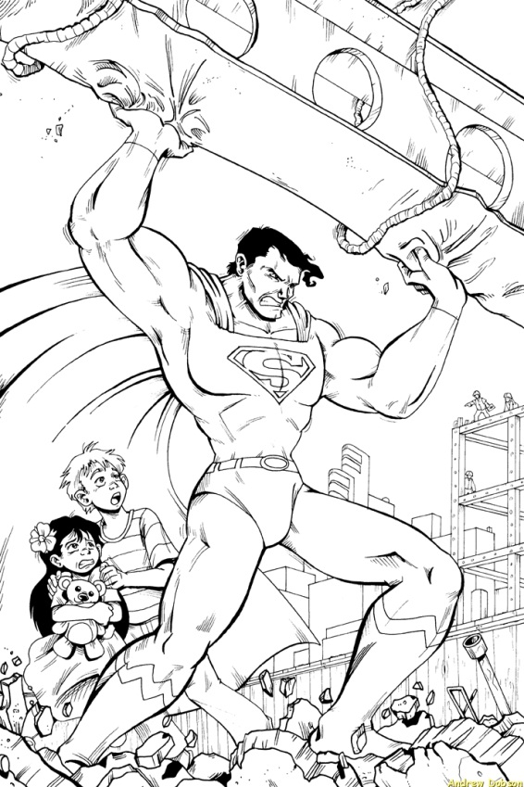
- Students are to use the Dodge & Burn tools in the image giving it shadows and a contrasting realistic look.
- Students are to save the original line art photo as Original_Lineart as a jpg in a new folder called Line Art in your Photoshop folder.
- Students are to save the edited colored in file as LineArt_edited as a .jpg and a .psd file in the same folder.

Grade Scale
Folder/File Names _____ 20pts
Original Image _____ 20pts
Edited Image _____ 20pts
Details/Doge/Burn _____ 40pts
TOTALS _____ 100pts

